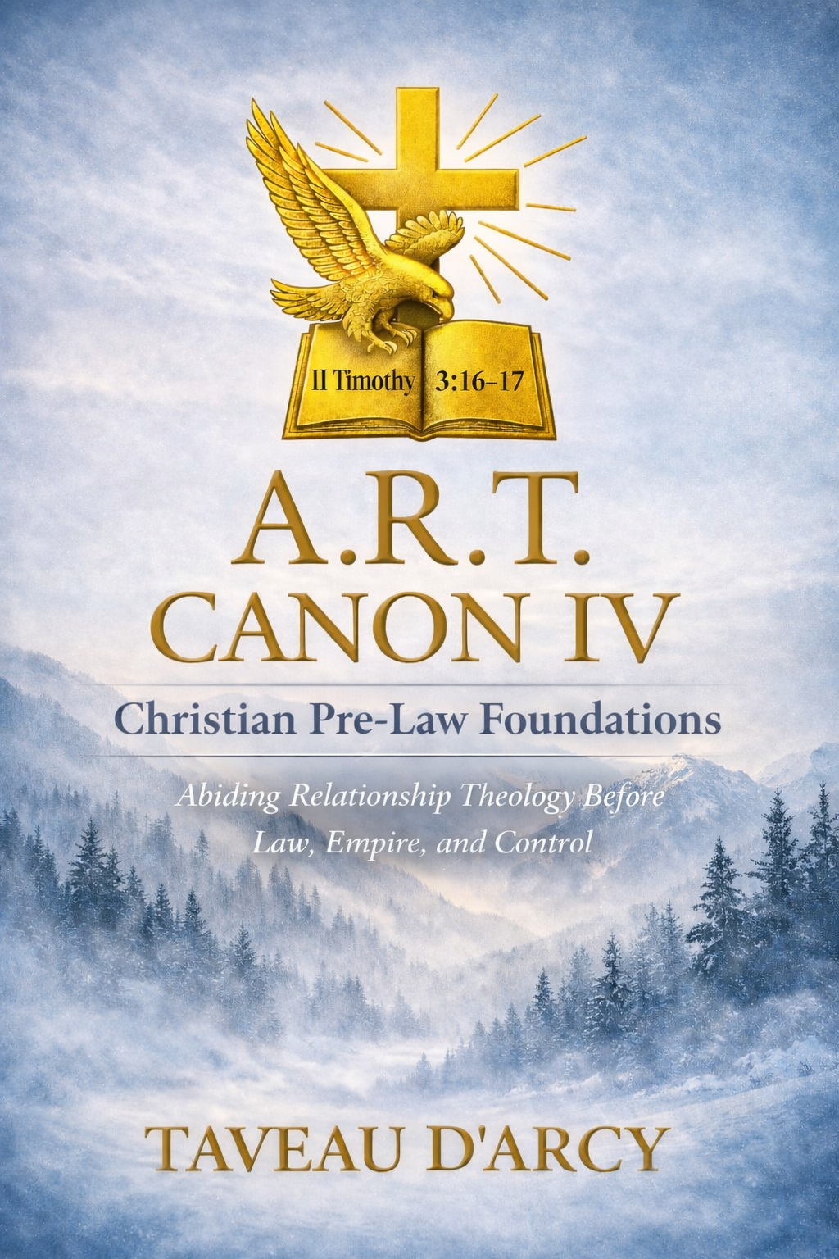

A.R.T. CANON IV
Christian Pre-Law Foundations
Abiding Relationship Theology
Before Law, Empire, and Control
By
Taveau D’Arcy

© 2026 Taveau D’Arcy Creative Leadership. All rights reserved.
© 2026 Taveau D’Arcy Creative Leadership.
All rights reserved.
No part of this publication may be reproduced, stored, or transmitted in any form or by any means without prior written permission of the publisher, except for brief quotations used in reviews or scholarly works.
Scripture quotations are taken from the King James Version (KJV) of the Holy Bible.

Use of Artificial Intelligence Declaration
This publication was developed with the assistance of artificial intelligence as a theological drafting, structural, and editorial support tool.
All biblical interpretation, theological conclusions, historical framing, ministry discernment, and final editorial decisions are the sole responsibility of the author, Taveau D’Arcy.
Artificial intelligence was used for clarity, organization, and language refinement only and does not replace human authorship, doctrinal accountability, or spiritual discernment.

Doctrinal Alignment
This work stands within historic, orthodox Christian theology.
Abiding Relationship Theology (A.R.T.) does not present a new gospel or replacement doctrine. It affirms the historic Christian faith as expressed in the Nicene Creed and the Apostles’ Creed.
This volume upholds:
- The Trinity
- The full deity and humanity of Jesus Christ
- Salvation by grace through faith in Christ
- The authority of Holy Scripture
A.R.T. is a relational framework for examining biblical leadership and spiritual fruit. It does not add to or replace Scripture and rejects any teaching that would constitute “another gospel” (Galatians 1:6–9).

Author’s Preface
This volume addresses a question that quietly governs many crises in modern Christian leadership:
What existed before law, hierarchy, institutional authority, and fear entered faith?
Scripture answers clearly: relationship came first.
Before Sinai, priesthood, kingship, and religious systems, God governed humanity relationally. Authority was entrusted, not imposed. Obedience flowed from intimacy, not coercion. Law entered only after relationship fractured.
Canon IV does not reject law, structure, leadership, or discipline.
It restores them to their proper theological order.
Abiding Relationship Theology (A.R.T.) is not a new doctrine.
It is a recovery of the Church’s original relational architecture.
— Taveau D’Arcy

What Canon IV Is
Canon IV is a biblical examination of authority before law.
It traces Scripture from Eden forward to show how God originally exercised authority through relationship, presence, and trust, and how authority deteriorates when it becomes transactional, fear-based, or controlling.
Canon IV is:
- Scripture-first
- Historically grounded
- Relationally framed
- Pastorally sober
- Apostolically responsible
It is written for:
- pastors and ministry leaders
- parents and mentors
- believers wounded by harsh religious systems
- thoughtful Christians seeking clarity without compromise
Canon IV evaluates patterns and fruit using Scripture as the final authority.

What Canon IV Is Not
Canon IV is not:
- an attack on the Church
- a rejection of leadership
- a psychological self-help book
- a rebellion manifesto
- a dismissal of holiness or order
It does not teach:
- that all authority is abusive
- that accountability is unnecessary
- that structure equals oppression
Canon IV insists authority is God-designed, but how authority is exercised reveals its source.

Core Definitions
A.R.T. — Abiding Relationship Theology
God governs through relationship before regulation.
Authority flows from presence, not pressure.
Correction occurs within dignity, not humiliation.
Transaction Core
Authority operating by exchange rather than relationship:
“I accept you if you comply.”
Common markers include fear-based obedience, performance pressure, and conditional belonging.
Authority (Biblical)
Stewardship, not ownership.
Given to protect life, cultivate growth, and preserve dignity.
Submission (Biblical)
Relational cooperation, not forced compliance.
It assumes moral agency and access to God.
Fruit as the Test
Authority is measured by its fruit (James 3:17), not its claims.

How to Read Canon IV
Canon IV speaks to:
- scholars and trained ministers
- pastors and leaders
- everyday and wounded believers
Each section:
- begins with Scripture
- interprets Scripture in context
- applies Scripture relationally
This book is not written to win arguments.
It is written to restore discernment.
Read slowly.
Let Scripture speak before systems do.

Canon IV Roadmap
Canon IV explores authority before law and what happens when authority shifts from relationship to transaction.
It traces:
- Eden’s relational authority
- the Fall and relational fracture
- the rise of transactional systems
- God’s preservation of relational leadership
Canon IV prepares the theological transition into later discussions of law, institutions, prophets, and Christ’s restoration of relational authority.

Complete A.R.T. Canon IV Table of Contents

Author’s Preface
What Canon IV Is — and Is Not
Core Definitions
How to Read Canon IV
RT CANON IV — RELATIONSHIP BEFORE AND BEYOND LAW
FOUNDATIONS
- How to Lead Like Jesus Without Hurting People
- Eden: Relationship and Authority Before Law
- The Fall: Relationship Rupture and Authority Distortion
- Cain vs Abel: Birth of Transaction Religion

FAMILY & FORMATION
5. Noah: Relational Breakdown and Cultural Violence
6. Abraham and Sarah: Relationship Under Promise Pressure
7. Jacob: Family Relationships and Leadership Formation
8. Levi: From Violence to Priesthood Tension

NATIONAL LEADERSHIP
9. Moses: Leadership Under Relational Pressure
1o. Moses and Institutional Authority Formation
11.Miriam: Correction and Relational Restoration
12. Deborah: Governing Without Domination
13.Korah: Transactional Mutiny vs Relational Authority
14. Eli: Passive Authority and Defiled Relationships
15. Samuel: Abiding Leadership vs Transaction Leadership

PROPHETIC WITNESSES: GOD CALLS BACK TO RELATIONSHIP
16. Micah: Relationship vs Religious Bargaining
17. Isaiah: When God Rejects Worship Without Relationship
18. Hosea: Loyal Love vs Ritual Religion
WISDOM & TRAUMA — PSALMS AS RELATIONAL THEOLOGY
19. Psalm 120: Living Among Lying Tongues and Accusatory Power
20. Psalm 124: Escaping Predatory Relationships Without Losing the Soul
21. Psalm 143: Accusation, Relationship Damage, and the Ruin of Transactional Power
22. Psalm 137: When Family,Lives and Great National Culture Are Lost
CONCLUSION
23.The Final Witness: Relationship Has Always Been God’s Desire

Dedication
This work is dedicated to both of my good parents
Rev. M. Kimball Johnson Jr. and Naomie (Nonie) Mitchell Simons Johnson
In gratitude for their quiet discernment, joyful wisdom, gentle humor, and unwavering respect for all people. Through their example, I learned that true Christian leadership does not need noise, fear, or domination to be powerful. They modeled a gracious, diverse, and welcoming Christian community grounded in humility, kindness, and biblical truth.
Their influence helped shape my understanding that discernment can be peaceful, correction can be loving, and unity can be real across cultures, backgrounds, and traditions. This book reflects the spirit of their teaching and example.
And I also dedicate this to every believer who has sought God in relationship rather than domination,
every leader who has chosen servant leadership over control,
and every wounded soul seeking restoration in Christ.
May this work honor Jesus Christ, the Chief Shepherd,
and strengthen relational authority in His Body.

ABIDING RELATIONSHIP THEOLOGY (A.R.T. AND TRANSACTION THESIS
After the Fall, leadership and ministry progressively drift from relationship with God into transactional systems marked by accusation, control, fear, and eventually monetized power — while God repeatedly calls His people back to relationship (A.R.T.).
That thesis is:
- Biblical
- Coherent
- Traceable from Genesis to the Prophets
- Defensible to traditional theologians
You nor I, when using this authentic Bible perspective, are not being scattered. We’re just examining, tracing and evaluating “relationship, transaction” cause → effect.

2. Defining the two systems at work in the Earth every day (and today!)
A. A.R.T. — Abiding Relationship Theology
In leadership and ministry, A.R.T. means:
- Authority flows from ongoing relationship with God
- Correction is restorative, not punitive
- Identity is given by God, not earned
- Ministry is service, not leverage
- Obedience flows from trust, not fear
- God is present, not mediated by systems
Biblically:
- Eden (God walking with humans)
- Abraham (belief counted as righteousness)
- Moses before Sinai (burning bush, face-to-face)
- Prophets calling people back to God Himself
- Jesus (“Abide in me”)
- Acts 15 (shared discernment, not domination)
A.R.T. is how God governs when relationship is intact.
Transaction-core leadership replaces relationship with exchange:
- “If I do X, God owes me Y”
- “Blessing must be earned”
- “Correction proves rejection”
- “Authority enforces compliance”
- “Access to God is mediated”
- “Fear maintains order”
Transaction-core produces:
- Accusation
- Performance identity
Control
B. Transaction-Core Leadership & Ministry

- Religious leverage
- Eventually, money + power systems
This is not theoretical — Scripture shows it unfolding.

3. The biblical progression this writer and this A.R.T. Canon Theology book are tracing (in a basic overview )
1. The Fall
Leadership effect:
- Fear replaces trust
- Shame replaces openness
- Blame replaces shared responsibility
Ministry effect:
- God is no longer approached freely
- Humans begin managing themselves through hiding and self-justification
This is the soil transaction grows in.

2. Cain
Cain is the first transactional worshipper.
Leadership/ministry effect:
- Offering becomes performance
- God’s correction is heard as rejection
- Comparison replaces calling
- Accusation justifies violence
Cain introduces:
- Transactional worship
- Accusatory identity
- Punitive leadership logic
This is where ministry becomes dangerous.

3. Esau / Edom
Esau embodies transactional short-term thinking:
- Birthright exchanged for appetite
- Covenant despised for immediacy
Edom later becomes:
- Bitter
- Hostile
- Opportunistic
Psalm 137 shows Edom rejoicing over Jerusalem’s fall — transactional hatred, not covenant grief.
Leadership/ministry effect:
- No loyalty to God’s purposes
- Opportunism replaces covenant love
- Joy at another’s destruction
Obadiah and Malachi condemn this spirit.

4. Levi (early → institutional)
Early Levi:
- Rage framed as justice
- Violence used to defend honor
Later Levi:
- Becomes mediator of God’s presence
- Holds teaching authority
- Handles offerings and material support
This introduces risk:
- Access can be controlled
- Ritual can replace relationship
- Ministry can become transactional
Levi is not evil — but systems invite drift.

5. Eli and his sons
This is transactional ministry fully visible:
- Priests take offerings by force
- Sexual exploitation
- God’s presence treated casually
- Authority maintained by position, not holiness
Leadership effect:
- Passive leadership enables corruption
- Ministry becomes self-serving
- God’s voice grows rare
This is transaction-core ministry in operation, not theory.

6. Micah (and the Prophets)
Micah is not early — but he is God’s corrective voice.
Micah exposes:
- Priests who teach for money
- Prophets who prophesy for pay
- Leaders who rule by gain
Micah 6:8 is a return-to-A.R.T. call:
Walk humbly with your God
Not:
- Pay more
- Perform better
- Submit harder
But relationship.

4. Why this still belongs together (in our sound reason)
This A.R.T. Canon is not randomly adding figures.
It is showing:
- Cause (Fall, Cain)
- Pattern formation (Esau, Levi)
- System corruption (Eli’s sons)
- Prophetic correction (Micah, Obadiah, Malachi)
That is a single theological arc:
When relationship is lost, ministry becomes transactional. When transaction dominates, God sends prophets to call people back to relationship.
That is legitimate biblical theology.
Sincerely, Apostle Founder, Leader EORR Cross Body Unity Ministry Move
- Taveau D’Arcy

THIS BOOK IS coming shortly on this site (as a PDF) but in a few days on Amazon, Kindle, Barnes and Noble, Apple, Kobo and more booksellers, ALSO in both

E book and Paperback

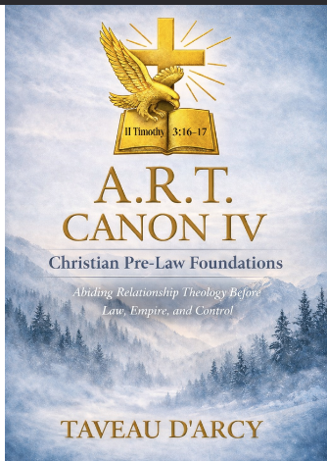
About 240-280 pages

Chapters 2 and 3 below

Same Abiding Relationship Theology (A.R.T.)

back in the Pre Law Garden

Sample Chapter 2

Eden: Relationship and Pure Authority Before the Need For Law

Pre-Garden Fall Organic A.R.T. CORE Culture

(C) 2026 Taveau D’Arcy Creative Leadership. All rights reserved.

1. The Foundational Question
Every system of Christian authority ultimately answers one question:
Did God design faith to be governed first by law, or first by relationship?
Modern theology often begins at Sinai.
Scripture begins in Eden.
Before there is Torah, before priesthood, before covenantal legislation, and before institutional structure, God establishes direct relational governance with humanity.
“And the LORD God commanded the man…”(Genesis 2:16, KJV)
This single sentence is one of the most theologically important lines in all of Scripture. It demonstrates that moral authority exists before codified law, and that divine instruction originally flows through relationship rather than regulation.

2. The Nature of God’s First Command
The Hebrew verb used here is:
צָוָה (tsāvāh) — to charge, appoint, entrust.
This is not the language of coercion. It is the language of stewardship. God is not issuing legislation; He is entrusting responsibility.
The command is not abstract. It is relational, personal, and direct.
Adam does not receive a legal code.
He receives the word of God.
This establishes a critical A.R.T. principle:
Authority is relational before it is institutional.

3. Relationship as the First Government
In Genesis 1–2, several realities exist without law:
• moral clarity
• accountability
• responsibility
• authority
• obedience
• consequence
What does not yet exist?
• a priesthood
• a sacrificial system
• written law
• judicial structure
Yet righteousness functions fully, because relationship with God is unbroken.
This demonstrates that law is not the foundation of morality.
Relationship is.
Paul later confirms this:
“Wherefore then serveth the law? It was added because of transgressions”(Galatians 3:19, KJV)
Law is a response to fracture, not God’s original design.

4. Order of Responsibility, Not Worth
Genesis 2:16–17 precedes the formation of Eve (Gen. 2:21–22). This is not a statement of superiority, but of accountability order.
Adam is the first steward of God’s command.
Leadership in Scripture always carries heavier moral weight, not higher personal value.
This is why later Scripture consistently corrects leaders more severely than followers (James 3:1).

A.R.T. Insight:
Responsibility, caring relationship precedes healthy safe authority.

5. Edenic Authority vs. Post-Fall Power
In Eden, authority is exercised through:
• obedience
• trust
• transparency
• relational alignment
There is no domination, no fear, no coercion, and no surveillance.
Power does not yet exist.
Power only appears when relationship is lost.
This is why Genesis 3 introduces the language of hiding, fear, and control — but Genesis 1–2 does not.

6. Theological Implications for Leadership
All later ministry failures trace back to this original distortion:
When relationship with God is no longer primary, authority becomes positional, and leadership becomes transactional.
Systems begin to replace intimacy.
Control replaces trust.
Performance replaces obedience.
Image replaces integrity.
This is not modern.
It is Adamic.

7. Christ as the Restoration of Edenic Governance
Jesus does not introduce a new form of religion.
He restores the original one.
“The Son can do nothing of himself…”(John 5:19, KJV)
This is Edenic leadership: authority flowing from abiding relationship.
John 15’s μένω (menō) — abide — is not mystical abstraction. It is functional governance.
Christ governs by union, not by force.

8. Canon Conclusion
Genesis 2 establishes the theological bedrock of A.R.T.:
• God governs through relationship.
• Authority is entrusted, not imposed.
• Obedience flows from intimacy.
• Law is not primary — relationship is.
Everything that follows in Scripture must be interpreted through this lens.
Where relationship abides, law serves.
Where relationship fractures, law dominates.
This is the beginning of all theology.

Sample of Fruit of Transaction

Chapter 13

Korah: Transactional Mutiny vs. Relational Authority
A.R.T. and the Testing of God-Given Leadership
© 2026 Taveau D’Arcy Creative Leadership. All rights reserved.

Numbers 16:1–3 (KJV)
“Now Korah… took men:
And they rose up before Moses… two hundred and fifty princes… men of renown:
And they gathered themselves together against Moses and against Aaron, and said… Ye take too much upon you… wherefore then lift ye up yourselves above the congregation of the LORD?”

I. Exegetical Foundations

“Took men”
Korah organizes support.
This is coordinated resistance, not a private question.
Biblically, rebellion often gathers numbers to create legitimacy.
Calling, however, does not come from consensus but from God.

“Princes… men of renown”
Hebrew nesi’im — lifted ones, recognized leaders.
Reputation does not equal divine appointment.
Influence does not prove calling.

“Gathered together”
Hebrew qāhal — to assemble.
A community can assemble for unity or for revolt.
The act itself is neutral; the motive defines it.

“Lift ye up yourselves”
Hebrew nāsā’ — to lift, elevate.
Korah accuses Moses of self-exaltation.
Yet Scripture reveals Korah himself seeks elevation.
Projection often masks ambition.

II. The Heart Issue
Korah is already a Levite (Num. 16:8–10).
He has sacred responsibility.
His problem is not exclusion.
It is dissatisfaction.
He desires priesthood God did not assign him.
Relational authority receives calling.
Transactional authority pursues position.

III. Moses’ Response

Numbers 16:4–5 (KJV)
“And when Moses heard it, he fell upon his face…”
Moses does not defend himself.
He seeks God.
Relational authority rests in God’s validation, not public opinion.

IV. Holiness and Calling

“Holy” — Hebrew qādôsh
Meaning: set apart by God.
Shared holiness does not erase distinct calling.
God sets apart both people and roles.
Confusing the two produces disorder.

V. The Test of Authority

Numbers 16:28 (KJV)
“…I have not done them of mine own mind.”
Moses clarifies the issue:
Divine sending vs. self-direction.
Relational authority is sent.
Transactional authority self-initiates.

VI. Judgment

Numbers 16:31–32 (KJV)
“…the earth opened her mouth, and swallowed them…”
This is not personality conflict.
It is rejection of God’s ordering.
When authority is seized rather than received, community stability is threatened.
God defends relational order.

X. Aftermath, Intercession, and Relational Leadership in Crisis

Numbers 16:41–48 (KJV)
“But on the morrow all the congregation of the children of Israel murmured against Moses and against Aaron, saying, Ye have killed the people of the LORD.
And it came to pass… that the cloud covered it, and the glory of the LORD appeared.
…Get you up from among this congregation, that I may consume them as in a moment.
And they fell upon their faces.
And Moses said unto Aaron, Take a censer… and go quickly unto the congregation, and make an atonement for them… for there is wrath gone out from the LORD; the plague is begun.
And Aaron… ran into the midst of the congregation… and made an atonement for the people.
And he stood between the dead and the living; and the plague was stayed.”

Korah’s Transaction CORE Thinking Means
Korah’s rebellion fractures the community.
But the greater test comes after the judgment.
Relational authority is proven in crisis, not in calm.
The people accuse Moses and Aaron again.
Yet Moses does not retaliate.
He sends help.
Relational leadership absorbs misunderstanding to protect the community.

A.R.T. Leadership Pattern
• Leaders intercede even for critics
• Responsibility outweighs reputation
• Protection of people comes first
• Authority serves life, not image

Transaction-Core Contrast
• Leaders withdraw after accusation
• Blame escalates division
• Fear governs decisions
• No one stands between harm and people

Canon Insight
Korah’s story does not end with judgment.
It continues with mercy and intercession.
God defends His order,
but He also preserves His people.
Relational authority includes both truth and protection.

Clear Summary
After Korah’s rebellion, the people blamed Moses again.
A plague began.
Aaron ran toward the people, not away.
He stood between death and life.
That is leadership in God’s design.
Good leaders do not protect their image first.
They protect people first.
Relational authority stands in the gap.
That is A.R.T.

VII. Aftermath and Intercession

Numbers 16:41–48 (KJV)
“But on the morrow all the congregation… murmured…
…make an atonement for them…
…he stood between the dead and the living; and the plague was stayed.”

“Murmured” — Hebrew lûn
Complaint rooted in unrest.
Fear turns grief into accusation.

“Make atonement” — Hebrew kāpar
To cover, reconcile, restore relationship.
Atonement here is relational repair.

“Stood between” — Hebrew ʿāmad
To remain, hold ground.
Aaron literally positions himself between life and death.
This is embodied intercession.

VIII. Theological Meaning
Korah’s rebellion tests authority.
The aftermath tests leadership heart.
The people accuse Moses again.
Yet Moses sends help.
Relational authority protects even those who misunderstand it.
Leadership is proven in crisis.

IX. A.R.T. vs Transaction Patterns

A.R.T.
• Intercedes for critics
• Protects community first
• Acts from responsibility
• Values life over reputation

Transaction-Core
• Withdraws after accusation
• Escalates blame
• Protects image
• Leads by fear

X. Conclusion
Korah treats leadership as position.
God treats it as stewardship.
One grasps.
One receives.
One divides.
One protects.
God’s authority is relationally assigned and relationally exercised.

Clear Summary
Korah wanted a role God did not give him.
He compared instead of trusting God.
Moses trusted God to defend the calling.
After judgment, the people blamed Moses again.
Aaron still ran to save them.
Good leaders protect people, even when accused.
Calling comes from God, not ambition.
That is A.R.T.

